Study on the Antioxidant Activity of Aloe-Emodin Metal Complex
Authors: LIU Mei-yan, PAN Xiao-li, LI Xue-bo, WU Bing
Affiliation: Key Laboratory of the Ministry of Education for the Standardization of Traditional Chinese Medicine, College of Pharmacy, Chengdu University of Traditional Chinese Medicine, Chengdu 611137, China
Corresponding Author: panpan_1388@126.com

Abstract
- Objective: To synthesize three kinds of metal complexes of aloe-emodin and compare the antioxidant activities of the ligands and the complexes.
- Methods: Three kinds of aloe-emodin metal complexes—aloe-emodin-iron (II), aloe-emodin-copper (II), and aloe-emodin-magnesium (II)—were synthesized by dissolving and stirring in anhydrous ethanol solvent, and their structures were characterized. The -methylene blue method and the DPPH method were used to determine the scavenging effect of the ligands and complexes on superoxide radicals (), hydroxyl radicals (OH), and DPPH radicals.
- Results: The three aloe-emodin metal complexes were successfully synthesized. According to the structural characterization, it was speculated that the complexes were formed between one metal ion (, , ) and two aloe-emodin molecules via the 9th carbonyl and 8th hydroxyl groups. Both the complexes and the ligand demonstrated scavenging effects on the three types of free radicals, with the complexes showing significantly stronger effects than the ligand (P<0.05).
- Conclusion: The coordination of aloe-emodin with metal ions such as , , and enhanced the antioxidant activity of the ligand itself.
Keywords: Aloe-emodin, Metal complex, Synthesis, Antioxidant

1. Materials and Methods
1.1 Instruments and Reagents
- Instruments: Fourier transform mid-infrared spectrometer, AM-400 superconducting NMR instrument, TDZ5-WS multi-rack automatic balancing centrifuge, UV-1700 UV-Vis spectrophotometer, EXSTAR 6000 thermal analyzer, DF-101S collecting-type constant temperature magnetic stirrer, BP211D electronic analytical balance, UPH-II-10T ultrapure water manufacturing system, and U-shaped 96-well plates.
- Reagents: Nitroblue tetrazolium chloride (NBT), 1,1-diphenyl-2-picrylhydrazyl (DPPH), tris(hydroxymethyl)aminomethane (Tris), reduced coenzyme I disodium salt (NADHNa₂), N-methylphenazinium methyl sulfate (PMS), anhydrous methanol, anhydrous ethanol, ammonia, copper chloride, ferrous sulfate, magnesium acetate, and DMSO were of analytical grade. Aloe-emodin powder (purity >98.5%) was also used.
1.2 Synthesis of Complexes
- Aloe-emodin-copper (II) and Aloe-emodin-iron (II) Synthesis: 270 mg (1 mmol) of aloe-emodin was dissolved in 60 mL of anhydrous ethanol at 60°C. A solution of 85.24 mg (0.5 mmol) in 15 mL of anhydrous ethanol was added dropwise. The pH was adjusted to ~10 with an ammonia-ethanol solution, forming a purple-black precipitate. The mixture was stirred at 60°C for 12 hours, left overnight, filtered, washed, and vacuum-dried at 40°C for 72 hours to yield the final product. The aloe-emodin-iron (II) complex was synthesized using the same method with .
- Aloe-emodin-magnesium (II) Synthesis: This was prepared similarly using 107.23 mg (0.5 mmol). The resulting purple-red solution produced no precipitate and was filtered. Purple-red crystals were obtained after slow evaporation at room temperature for about 3 weeks.
1.3 Characterization of Complexes
- UV Spectroscopy: Solutions of the compounds (5.0 × mol/L in anhydrous methanol) were scanned from 200-600 nm.
- Infrared (IR) Spectroscopy: Samples were mixed with KBr powder and pressed into pellets for IR analysis.
- Nuclear Magnetic Resonance (¹H NMR): ¹H NMR spectra were recorded in DMSO-d₆ solvent.
- Thermal Analysis (TG-DTA): Samples were heated from 25°C to 900°C at a rate of 10°C/min under a nitrogen flow of 30 mL/min.
- Titration: The metal content in the complexes was determined by titration after ashing the samples at 800°C. The Fe(II) and Cu(II) complexes were analyzed using sodium thiosulfate titration , while the Mg(II) complex was analyzed using EDTA titration.
1.4 Antioxidant Experiments
- Sample Preparation: Stock solutions of aloe-emodin and its metal complexes were prepared in distilled water and anhydrous methanol at concentrations of 0.156, 0.312, 0.625, 1.25, and 2.5 mg/L.
- Superoxide Radical () Scavenging Assay:
Under alkaline conditions, O₂⁻• radicals were generated through the auto-oxidation of pyrogallol [17].
In this experiment, the reaction system was slightly modified as follows: a 4 mL Tris–HCl buffer solution (0.05 mol/L, pH = 8) containing 1 mL of sample solution, 0.1 μmol NBT, 0.04 μmol PMS, and 0.2 μmol NADH–Na₂ was used.
After standing at room temperature for 5 minutes, the absorbance (Aₘ_{ẫu}) of the sample was measured at 386 nm. A blank control (A₀) was prepared by replacing the 1 mL sample solution with 1 mL distilled water. Each measurement was repeated three times, and the average absorbance value (Aₘ_{ẫu}) was recorded.
- DPPH Radical Scavenging Assay: The assay was conducted by mixing the sample solution with a DPPH solution in anhydrous methanol. After 30 minutes of reaction in the dark, the absorbance was measured at 518 nm.
- Hydroxyl Radical (OH) Scavenging Assay: This was performed using the -methylene blue system. After heating for 40 minutes, the absorbance was measured at 664 nm.
- Calculation: For all assays, the scavenging rate was calculated using the formula: Scavenging Rate (%) = (A₀ − Aₘ_{ẫu}) / A₀ × 100%.
1.5 Statistical Methods
Dữ liệu thực nghiệm được biểu thị dưới dạng x̄ ± s (giá trị trung bình ± độ lệch chuẩn). Việc so sánh giữa nhiều nhóm được thực hiện bằng phân tích phương sai một nhân tố (one-way ANOVA), và so sánh từng cặp giữa các nhóm được tiến hành bằng kiểm định t (t-test). Khi P < 0.05, sự khác biệt được xem là có ý nghĩa thống kê.
2. Results
2.1 General Properties
The synthesized complexes showed distinct changes in appearance and properties compared to the aloe-emodin ligand.
- Aloe-emodin-Mg (II): Purple-red solid.
- Aloe-emodin-Cu (II): Purple-black solid.
- Aloe-emodin-Fe (II): Brown-black solid. The complexes had higher melting points and were soluble in DMF and DMSO, slightly soluble in methanol and ethanol, and insoluble in water, acetone, ether, and chloroform.
2.2 UV Spectroscopy
The UV spectra showed that the absorption peaks of the complexes were red-shifted compared to the ligand, and new weak absorption peaks appeared around 520 nm for the Mg(II) and Cu(II) complexes, suggesting coordination occurred.
Table 1: Main UV Data of Aloe-emodin and its Metal Complexes
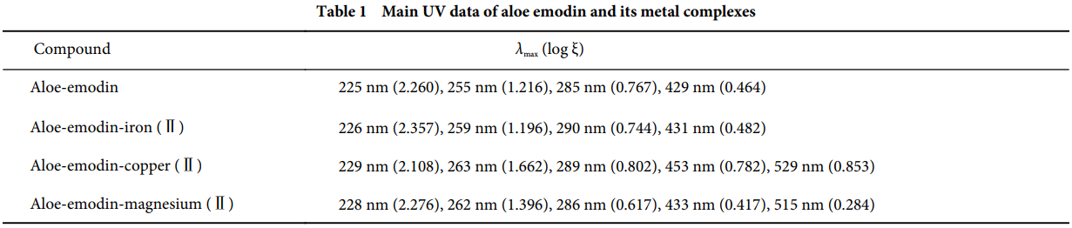
2.3 Infrared (IR) Spectroscopy
The IR spectra of the complexes showed shifts in the hydroxyl (-OH) and carbonyl (C=O) absorption peaks compared to the ligand, indicating their involvement in coordination. The appearance of new weak absorption peaks around 500 was attributed to the formation of M-O bonds.
Table 2: Main IR Data of Aloe-emodin and its Metal Complexes
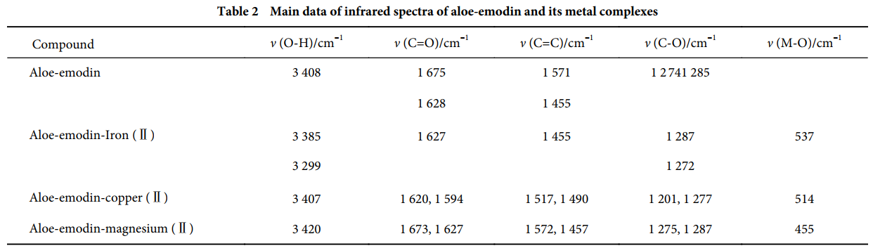
2.4 ¹H NMR Spectroscopy
Compared to aloe-emodin, the ¹H NMR spectra of the metal complexes showed significant changes, with multiplet peaks and a doubling of proton counts, suggesting a structure involving two ligand molecules per metal ion.
2.5 Thermal Analysis
The thermal analysis curves (Figures 1-3) showed that the complexes undergo multi-stage decomposition. The initial weight loss in all three complexes corresponds to the loss of two water molecules, indicating they are hydrates.
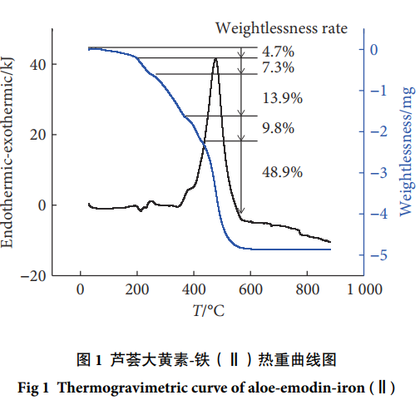
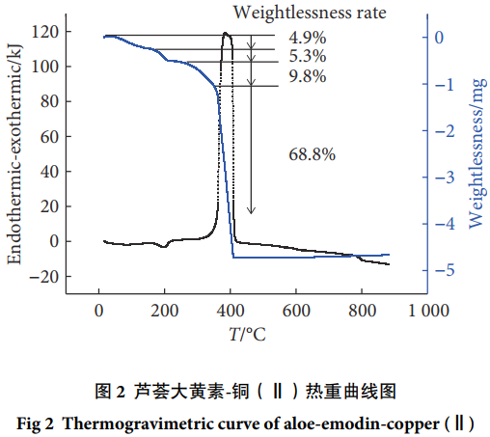
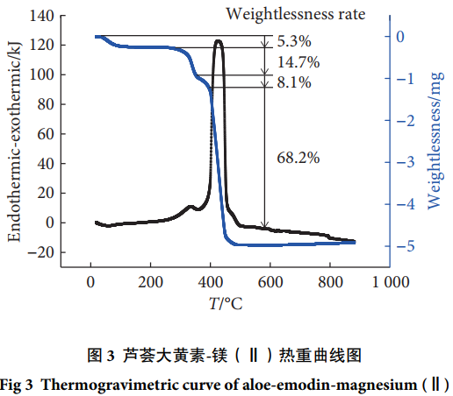
2.6 Titration Results
The measured metal content in the complexes was consistent with the theoretical values for a 1:2 (metal:ligand) stoichiometry.
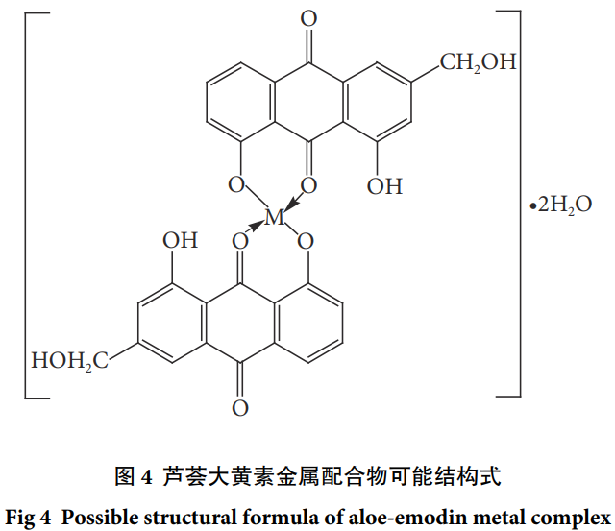
Table 4: Metal Ion Content in Complexes
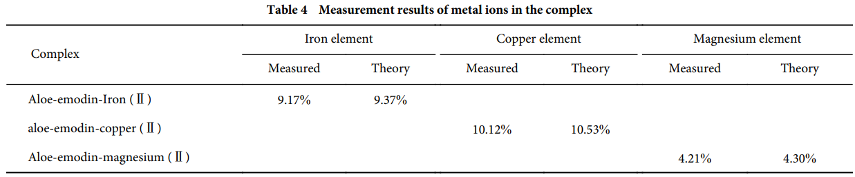
2.7 Antioxidant Activity Results
2.7.1 Ảnh hưởng của phối tử và phức chất đến khả năng loại bỏ gốc tự do O₂⁻• (Scavenging effect of the ligand and its complexes on O₂⁻• radicals)
Từ Bảng 5 cho thấy, aloe-emodin (lô hội đại hoàng tố) và các phức chất của nó đều có hoạt tính kháng gốc tự do O₂⁻•.
Trong một khoảng nồng độ khối lượng nhất định, tỷ lệ loại bỏ gốc O₂⁻• của cả phức chất và phối tử đều tăng theo nồng độ.
Tác dụng loại bỏ gốc O₂⁻• của các phức chất mạnh hơn rõ rệt so với phối tử aloe-emodin (P < 0.05).
Giá trị nồng độ hiệu quả bán phần (half effective concentration, EC₅₀) trong khả năng loại bỏ gốc O₂⁻• lần lượt là:
- Aloe-emodin: 6.03 mg/L
- Aloe-emodin–Fe(Ⅱ): 1.72 mg/L
- Aloe-emodin–Cu(Ⅱ): 0.98 mg/L
- Aloe-emodin–Mg(Ⅱ): 0.95 mg/L.
👉 Kết quả này cho thấy các phức chất kim loại của aloe-emodin có hiệu quả loại bỏ gốc tự do O₂⁻• mạnh hơn đáng kể so với aloe-emodin tự do.
Table 5: Scavenging Rates on Superoxide Radicals (%)
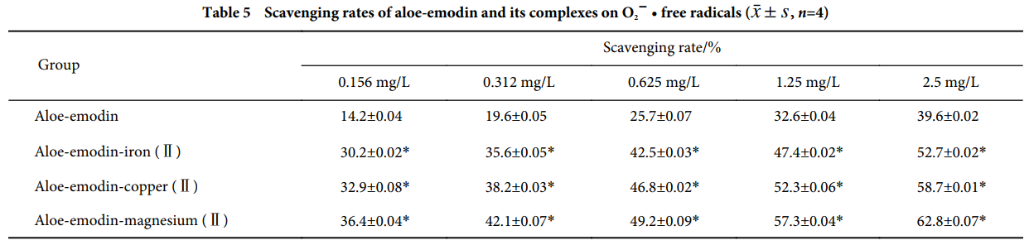
2.7.2 DPPH Radical Scavenging The complexes generally showed stronger scavenging activity than aloe-emodin (P<0.05), although the overall scavenging rates for DPPH were low (all below 31%).
Table 6: Scavenging Rates on DPPH Radicals (%)
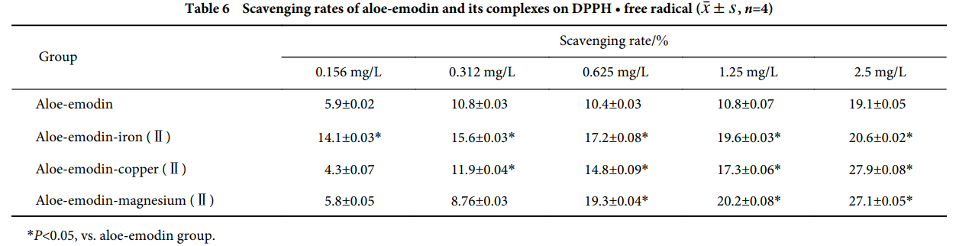
*P<0.05, vs. aloe-emodin group.
2.7.3 Hydroxyl Radical (OH) Scavenging All complexes exhibited significantly stronger scavenging activity against hydroxyl radicals than aloe-emodin alone (P<0.05).
- Activity Order: Aloe-emodin < Aloe-emodin-Mg(II) < Aloe-emodin-Fe(II) < Aloe-emodin-Cu(II).
- values: Aloe-emodin (4.88 mg/L), Fe(II) complex (0.52 mg/L), Cu(II) complex (0.23 mg/L), Mg(II) complex (0.77 mg/L).
Table 7: Scavenging Rates on Hydroxyl Radicals (%)
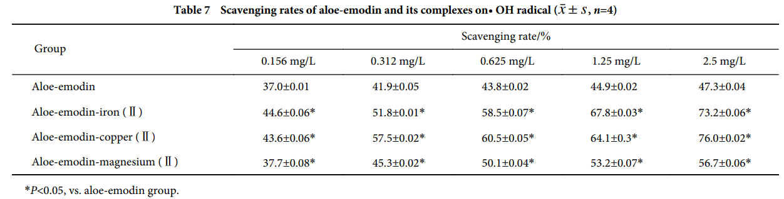
3. Discussion and Conclusion
This study successfully synthesized and characterized three novel metal complexes of aloe-emodin with Fe(II), Cu(II), and Mg(II). Structural analysis suggests that two aloe-emodin molecules coordinate with one metal ion through the 8-hydroxyl and 9-carbonyl groups. It is theorized that the 8-hydroxyl group is more reactive and prone to deprotonation than the 1-hydroxyl group due to the electron-donating effect of the 3-hydroxymethyl group.
The antioxidant assays demonstrated that all three complexes have significantly higher scavenging activity against superoxide, DPPH, and hydroxyl radicals compared to the uncomplexed aloe-emodin ligand. This enhancement is attributed to the synergistic effect resulting from the coordination of the aloe-emodin ligand with the metal ions (, , ). The chelation enhances the antioxidant capacity of the parent ligand molecule. The relatively low scavenging rates for DPPH may be due to the methanol solvent system, in which the ligand and complexes may not form stable intermediates.
In conclusion, complexing aloe-emodin with trace metal elements like iron, copper, and magnesium is an effective strategy to enhance its natural antioxidant properties.

